**Python project using GUI**

**ON**

***“Library Management System”***



Submitted by

**Name:** Anirudh Sannidhi

**Admission no.:** 12107958

**Roll no.:** RK21GPA11

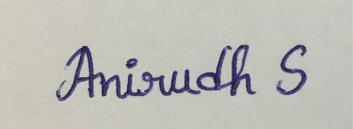

**Signature of the student**

**Introduction**

This project is a GUI interface of Library management system which is built using Tkinter module. Tkinter is the standard GUI library for Python. Python when combined with Tkinter provides a fast and easy way to create GUI applications. Library Management System is basically a platform that helps in maintaining the record of books and everything about when it was issued and when it was returned. Librarians can refer to the software and find out the current status of a book. This reduces the time and labour involved in maintaining a library and it also makes it much easier for a librarian to keep track of what books they have and what books are currently being borrowed by readers and also when the last date for them to return the book is.

**Objective**

1. The data of readers can be stored and maintained easily and referred to without much effort.
2. The software can be used in various organizations such as schools, colleges, reference libraries, national libraries, and public libraries.
3. It reduces the amount of human work involved.
4. Librarians don’t have to keep track of when a reader is supposed to return a book, they can just use the days remaining feature.

**Components**

1. **Login: -** This Is the very initial page and when we enter our details here, they will be verified through an already existing database in mysql and if the details are correct then it will direct you into the next home page where you can select if you want to return, issue or check the days remaining on a certain book using its unique token id.
2. **Forgot Password: -** If you happen to forget your password then you can click on this button which will direct you to a page where you will have to enter your user id and mobile number which has been linked to this account. After that the database will be checked to verify if such an account really exists and if it does then it will show a popup messagebox with your password written on it.
3. **Sign Up: -** If you are a new user then you can click on this button which will then direct you to a page where you will have to enter your data like you name, phone number, user id, etc. Keep in mind that if your phone number has not integer or has more than 10 digits it will show you an error message but if everything is fine then it will show you a success page.
4. **Issue book: -** If you want to issue a book to a reader then you can click on this button which will then redirect you to a page where you will have to give details such as your name, phone number, the book you want to borrow, etc. After entering the details and clicking on submit, you will be able to see your details along with a uniquely generated token code which reader will have to remember for future use and returning the book.
5. **Return book: -** If You want to return a book then all you have to do is just enter the token code given to you and click submit then it will remove the data from the table and your book can be returned.
6. **Dates remaining: -** If you want to check how many days will it be before a certain book is returned then you can just click on this button on the homepage which will then direct you to another page where if you enter the correct token number a popup messagebox appears telling you exactly how many days you have till the book is returned.

**Screenshots**

Login page buttons

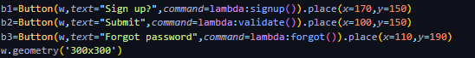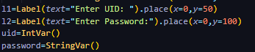

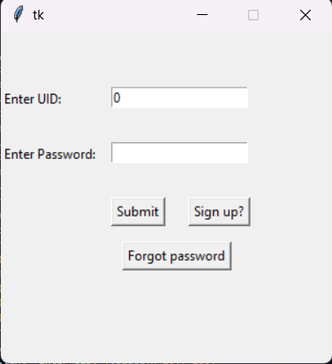

Login page errors messagebox

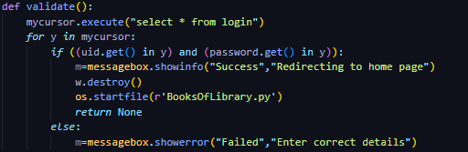

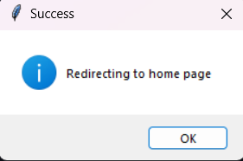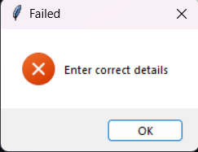

Forgot password

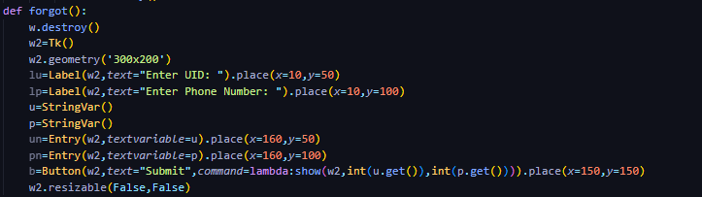

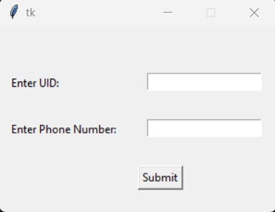

Signup

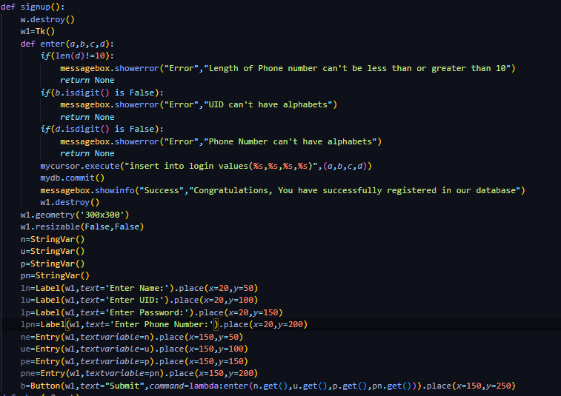

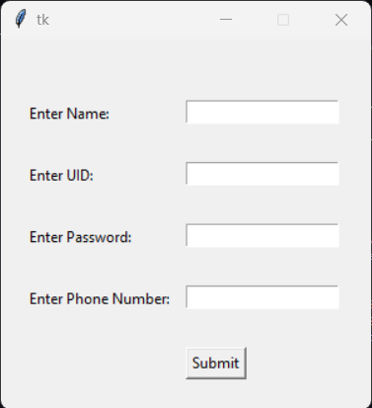

Homepage(after login)

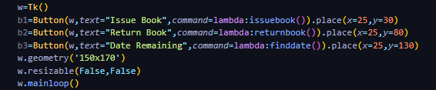

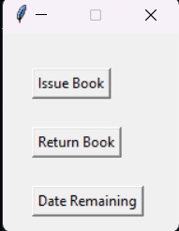

Issue Book

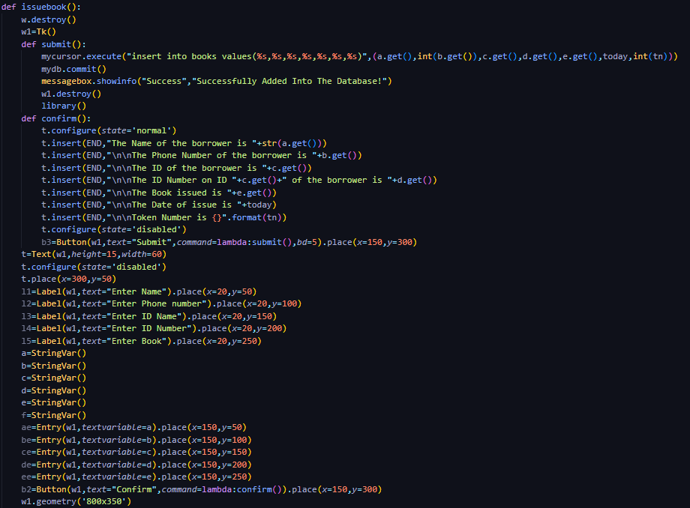

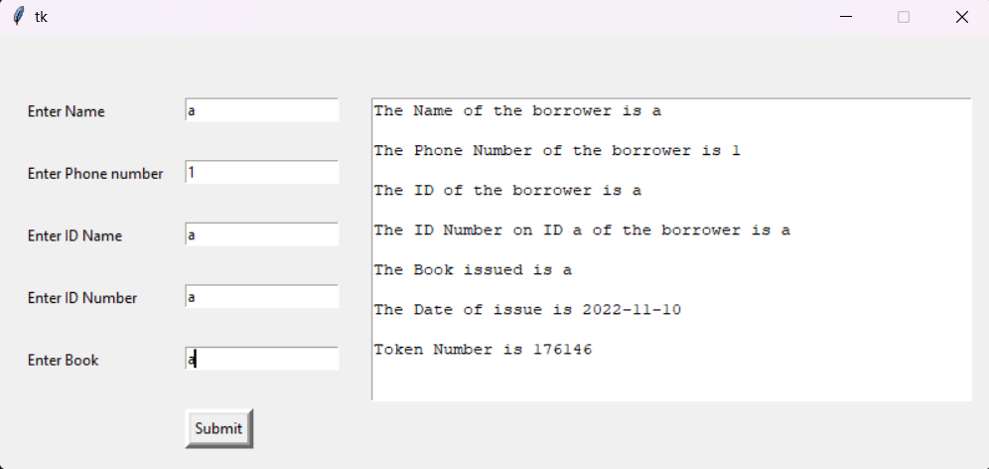

Return Book

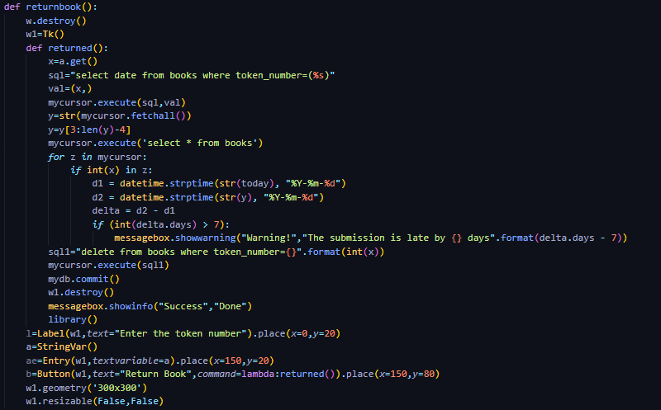

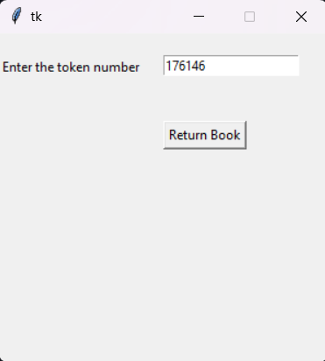

Dates remaining

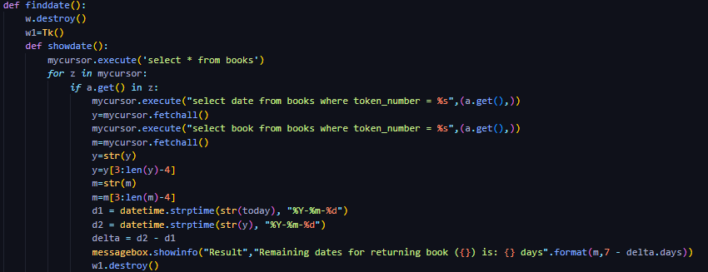

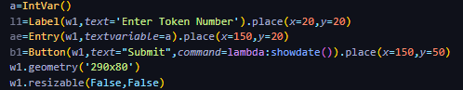

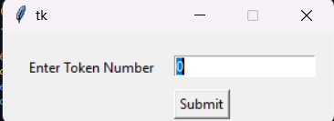

**SQL Screenshots**

Login Database

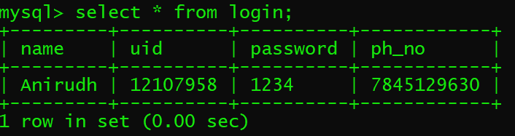

Books Database

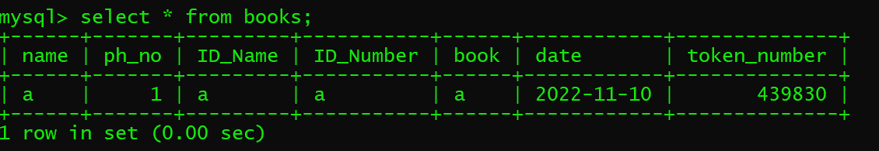

The above mentioned are the screenshots of all the components that have been used in this project along with the sql database used to maintain record of all readers and the books that have been issued or returned.

**Conclusion**

This report gives an overview of library management system which consists of several functions such as issuing a book, returning a book and also checking when the book will be returned by the reader, and also provides an idea about the use of database with python for storing the entries. This project has helped me understand the concepts of GUI and implementation using Tkinter and helped me strengthen my basics of Sql. I hope to add more features added to this Library management system which will in turn make this software even more reliable.

**References**

1. <https://camudigitalcampus.com/guide>
2. <https://www.tutorialspoint.com/python>
3. <https://www.geeksforgeeks.org/python-gui-tkinter/>
4. <https://www.geeksforgeeks.org/python-tkinter-tutorial/>
5. [tkinter — Python interface to Tcl/Tk — Python 3.11.0 documentation](https://docs.python.org/3/library/tkinter.html)

**GitHub link**

<<insert-link-here>>

To check the full application, you can download and run “LibraryManagementSystem.py” and if you just want to see the internal working and not the login page then you can directly run “BooksOfLibrary.py”.